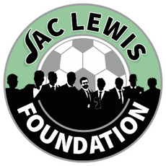

  - City Cluster Counselling Service
  - FREE Sleep Hygiene Workshop

- This workshop is designed to educate participants on the best practices for achieving restful and restorative sleep.
- The workshop will cover the benefits of creating a tranquil sleep environment and practical tips will be shared.
- Interactive activities included guided relaxation techniques, such as progressive muscle relaxation and mindful breathing exercises.
- Attendees will be encouraged to share their personal challenges with sleep and receive personalised advice to help them overcome these obstacles.
- By the end of the workshop, participants will feel more empowered and equipped with effective strategies to improve their sleep hygiene.

  - 11th September 2024 10-12pm
Online - Via Zoom
To book onto the workshop please:
Email Admin@jaclewisfoundation.co.uk
Call or Text 03301336510

